SISSS00132
Swimming and
Water Safety Teacher

Workplace Induction and On-the-job Workbook

Participant Name:

Royal Life Saving Society WA Inc
12 McGillivray Road,
Mt Claremont WA 6010

training@royallifesavingwa.com.au
www.royallifesavingwa.com.au

© 2023 Royal Life Saving Society WA Inc

The copyright disclaimer under Section 107
of the Australian Copyright Act 1968 allows
the fair use of copyrighted materials for the purposes of Education and research.

Candidate Details
Name: |  |  |  | Date of birth:
Address:
 |  |  |  | Post code:
Training  course venue: |  |  |  | Training  course date:
Email: |  |  |  | Phone:
Name of Aquatic
Facility (Workplace induction)

If you are an existing Swim Teacher, with Skillset SISSS00132 - Swimming and Water Safety Teacher, please use
our online application:
https://royallifesavingwa.com.au/programs/ community-trainers/swimming-and-water-safety-teacher-requalification

Approved Workplace Supervisor
Name: |  |  |  | Date of birth:
Email: |  |  |  | Phone:
Licence number:

For any queries throughout the completion of this document, please contact Royal Life Saving WA.
Royal Life Saving WA
PO Box 28, Floreat Forum WA 6014, Australia
Email: swimteacher@royallifesavingwa.com.au
Phone: 08 9383 8200

About the Application
This application contains a workplace induction checklist, individual declarations and evidence
of practical teaching sessions that need to be completed “on the job” to apply for your Swim Teacher Licence.
The application is an official document that provides evidence of:
- Skills and knowledge demonstrated in the workplace
- Workplace shifts under supervision
- Workplace induction
- A Workplace Supervisor providing feedback where applicable
Candidates submitting this application must have successfully attained the following units of competency from the SISSS00132 Swimming and Water Safety Teacher Skillset:
- SISCAQU020 Perform water rescues
- SISCAQU023 Plan swimming lessons
- SISCAQU024 Teach water familiarisation, buoyancy and mobility skills
- SISCAQU025 Teach water safety and survival skills
- SISCAQU026 Teach swimming strokes

Your Responsibilities
You are responsible for ensuring that:
- The application is completed in its entirety and submitted in good condition
- The application is made available to your employer and/or Workplace Supervisor when required
- Your Workplace Supervisor keeps your records up to date by signing the appropriate sections at the completion of each session.
Upon completion of the required components you must return your application to Royal Life Saving WA. You have three months to complete the on the job component after completion of the course. Please contact Royal Life Saving WA if any issues.

Approved Workplace Supervisor
An Approved Workplace Supervisor is someone that has the appropriate skills, knowledge, and expertise to be able to monitor your progress.
A Workplace Supervisor may be:
- A qualified Swim Teacher, licenced to the facility at which you are being inducted and with a minimum of 12 months or 700 hours of teaching experience, or
- The Swim school supervisor / manager or equivalent, or
- A Risk Manager/WHS Manager within the Council or Organisation with suitable Swim Teacher knowledge
They should be actively involved in swim school activities and current in industry knowledge. Where possible, your Workplace Supervisor should be listed with Royal Life Saving as an Approved Workplace Supervisor
If you do not have access to an appropriate person to act as your Workplace Supervisor, please contact Royal Life Saving WA for assistance or visit the following link of approved Workplace Supervisors: https://royallifesavingwa.com.au/programs/vocational-training/courses/swimteacher-royal-life-saving/workplace-supervisor-locations

Workplace Supervision
Your Workplace Supervisor is expected to:
- Supervise the student during their teaching practice session
- Provide a safe workplace while you are undertaking these on-the-job activities
- Verify that you are following your organisation’s policies and procedures
- Provide feedback to you during your supervised teaching practice
- Maintain records relating to any other workplace training, progress & achievement
- Liaise with Royal Life Saving regarding any issues that may arise during the application process

Activity Schedule
Assessment Activity | Completion Date
Part 1  Workplace Induction Checklist | This should be completed on your first day of Workplace Placement.
Part 2  Organisational Work Health and Safety | Completed as soon as reasonably possible after placement in your workplace.
Part 3  Supervised Teaching Practice | Completed as soon as reasonably possible after placement in your workplace.
Part 4  Workplace Supervision Verification | Completed upon completion of the components listed above.

Please Note: Submitting this application does not guarantee issuance of a Swim Teacher Licence. Incomplete applications will be returned to the candidate for completion.

Initial Training and Qualifications
All Swimming and Water Safety Teachers
https://www.guidelines.royallifesaving.com.au/single-post/gspo-clarification-of-trainingqualificiations
RLSSA GSPO. SV2. Swimming and Water Safety Teachers
RLSSA GSPO. 2.8. Licensing

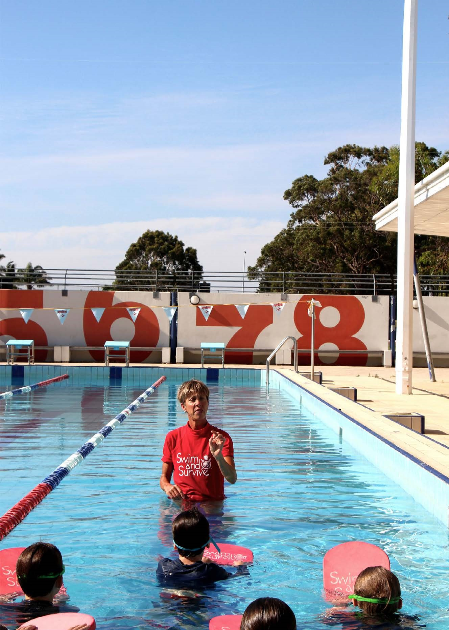

Part 1:
Workplace Induction Checklist
This Checklist relates directly to safety issues in the workplace and is aligned with the Guidelines for Safe Pool Operation (GSPO).
This Checklist needs to be completed by the Student on Day 1 of practical hours in consultation with your Workplace Supervisor.
I confirm that I have an understanding and knowledge in the following areas of facility operations. | Y/N or N/A
- Physical layout
- Location of exits (including emergency and evacuation)
- Location and use of first aid rooms
- Supervisory Procedures
- Communication systems
- Incident control
- Fault reporting
- Personnel, policies, and procedures
- Workplace staffing
- Employee roles and responsibilities
- Uniform
- In-service training
- Workplace health and safety (where applicable)
- Incident reporting procedures
- Employee/employer responsibilities
- Emergency Action Plan
- First aid procedures
- Disorderly behaviour
- Weather
- Emergency whistles
- Evacuation procedures
- Follow instructions of the lifeguard
- Use of outdoor pools during electrical storms
- Critical incident stress debriefing
- Debrief policy
- Confidentiality
Note to Student: The policies and procedures above are based on a generic facility and are not exhaustive. If your workplace has specialised requirements, the student should be inducted appropriately.
Student  Name: | Student  Signature: | Date:

Part 2:
Organisational Work Health & Safety

Student Declaration

I confirm that I accept the following terms and conditions: | Y/N
I agree to become a Member of Royal Life Saving and I have read, understood and agree to comply with the Royal Life Saving WA constitution and relevant Policies related to membership.
https://royallifesavingwa.com.au/support-our-work/be-a-member/about-membership/ aims-and-objectives
I agree to abide to the Royal Life Saving WA Swim Teacher Code of Behaviour.
https://royallifesavingwa.com.au/about/child-safeguarding
I agree to abide to the Royal Life Saving WA Child Safe Code of Conduct.
https://royallifesavingwa.com.au/about/child-safeguarding
I agree to abide to the Royal Life Saving WA Handling Guidelines.
https://royallifesavingwa.com.au/about/child-safeguarding
I confirm that I am in good health and physical fitness for the duties of a swimming and water safety teacher.
I confirm that I will inform my employer if my ability to perform my duties as a swimming and water safety teacher is compromised by way of injury, or changes to my health and well-being.
I do not have any criminal convictions or findings of guilt for sexual offences, offences related to children or acts of violence.
I do not have any criminal charge pending before the courts.
I have not had any disciplinary proceedings brought against me by an employer volunteer association involving child abuse, sexual misconduct or harassment, other forms of harassment or acts of violence.
I will at all times comply with any working with children legislative requirements that may apply to me and I will maintain a valid working with children check.
I will notify Royal Life Saving WA and my employer immediately on becoming aware that any of the matters set out in the above paragraphs have changed.

Student  Name: | Student  Signature: | Date:

Part 3:
Supervised Teaching Practice

For the WORKPLACE Supervisor
In order to receive the Swim Teacher Licence, candidate must undertake at least four (4) controlled Learn to Swim rostered shifts on their own, or until the Workplace Supervisor considers candidate ready to deliver lessons independently.
These shifts are not inclusive of observation and assistance shifts. Each shift should be structured and aligned to RLSSWA Curriculum for stages 1 to 16, or a learn to swim program that is aligned to the National Swimming and Water Safety Framework Swimming or Water Safety Continuum for Stages 1 to 9.
Practice instructing skills and strand progressions, delivering and adjusting lesson plans, reporting a child’s progress using the assessment guide and stage certificates.
Where possible, the Learn to Swim sessions must provide variety to the level of learners.
Please contact RLSS for a Supervisors Handbook or QR code if required
If at any stage the candidate is not suitable, or requires further training, please contact RLSSWA on training@royallifesavingwa.com.au
Once supervised training has been completed, the workbook and additional materials, are to be emailed to swimteacher@royallifesavingwa.com.au .

Session 1 | Date/Duration of lesson: | Class level:

Workplace Supervisor:
Did the candidate satisfactorily demonstrate their ability to deliver swimming and water  safety lessons? | Y/N
The points below are to assist you.
- Satisfactorily conduct the swimming and water safety lesson according to industry and workplace requirements
- Maintain class control at all times
- Appropriately identify any students at risk or with special needs
- Recognise and correct, incorrect swimming techniques or skills
- Identify any hazardous behaviour
- Take correct action with students who were displaying hazardous behaviour
- Identify any challenging behaviour and manage appropriately
- Promptly and correctly deal with any hazards associated with environmental conditions.

Please note Supervisor Feedback must be provided at the end of each session.
Additional Workplace Supervisor feedback/comments:

Student:
Provide a description of activities/skills delivered and self-reflection of the session. Please provide any adjustments made to the lesson plan you delivered or what you would do differently next time and submit with your workbook.

Session 2 | Date/Duration of lesson: | Class level:

Workplace Supervisor:
Did the candidate satisfactorily demonstrate their ability to deliver swimming and water  safety lessons? | Y/N
The points below are to assist you.
- Satisfactorily conduct the swimming and water safety lesson according to industry and workplace requirements
- Maintain class control at all times
- Appropriately identify any students at risk or with special needs
- Recognise and correct, incorrect swimming techniques or skills
- Identify any hazardous behaviour
- Take correct action with students who were displaying hazardous behaviour
- Identify any challenging behaviour and manage appropriately
- Promptly and correctly deal with any hazards associated with environmental conditions.

Please note Supervisor Feedback must be provided at the end of each session.
Additional Workplace Supervisor feedback/comments:

Student:
Provide a description of activities/skills delivered and self-reflection of the session. Please provide any adjustments made to the lesson plan you delivered or what you would do differently next time and submit with your workbook.
Session 3 | Date/Duration of lesson: | Class level:

Workplace Supervisor:
Did the candidate satisfactorily demonstrate their ability to deliver swimming and water  safety lessons? | Y/N
The points below are to assist you.
- Satisfactorily conduct the swimming and water safety lesson according to industry and workplace requirements
- Maintain class control at all times
- Appropriately identify any students at risk or with special needs
- Recognise and correct, incorrect swimming techniques or skills
- Identify any hazardous behaviour
- Take correct action with students who were displaying hazardous behaviour
- Identify any challenging behaviour and manage appropriately
- Promptly and correctly deal with any hazards associated with environmental conditions.

Please note Supervisor Feedback must be provided at the end of each session.
Additional Workplace Supervisor feedback/comments:

Student:
Provide a description of activities/skills delivered and self-reflection of the session. Please provide any adjustments made to the lesson plan you delivered or what you would do differently next time and submit with your workbook.
Session 4 | Date/Duration of lesson: | Class level:

Workplace Supervisor:
Did the candidate satisfactorily demonstrate their ability to deliver swimming and water  safety lessons? | Y/N
The points below are to assist you.
- Satisfactorily conduct the swimming and water safety lesson according to industry and workplace requirements
- Maintain class control at all times
- Appropriately identify any students at risk or with special needs
- Recognise and correct, incorrect swimming techniques or skills
- Identify any hazardous behaviour
- Take correct action with students who were displaying hazardous behaviour
- Identify any challenging behaviour and manage appropriately
- Promptly and correctly deal with any hazards associated with environmental conditions.

Please note Supervisor Feedback must be provided at the end of each session.
Additional Workplace Supervisor feedback/comments:

Student:
Provide a description of activities/skills delivered and self-reflection of the session. Please provide any adjustments made to the lesson plan you delivered or what you would do differently next time and submit with your workbook.

Part 4 Workplace Supervisor Verification
Workplace Supervisor to verify: | Y/N
- Has the student been inducted into their facility of placement?
- Did the student demonstrate sufficient knowledge on the above which relates to their duties as a Swim Teacher during these on-the-job session?
- Did the candidate complete at least four (4) Swim Teacher sessions under supervision and demonstrate their ability to deliver swimming and water safety lessons safely?
- Did the student demonstrate their ability to meet the requirements for a swimming and water safety teacher?

Additional Workplace Supervisor feedback/comments:

Workplace  Supervisor  Name: | Workplace  Supervisor  Signature: | Date:

Swim Teacher Checklist
Please ensure the following are attached prior to submitting your completed workbook | Swim Teacher | Office  Use
Working with children check
CPR Awards
Signed Workplace Induction
On-the-Job Lesson plans attached with adjustments and reflections
Passport style photograph (must be in colour, can be physical or digital).

Please send completed applications to:
Royal Life Saving WA
PO Box 28, Floreat Forum WA 6014, Australia
Email: swimteacher@royallifesavingwa.com.au
Phone: 08 9383 8200

OFFICE USE ONLY
Processed by: | Date:

